***Note: This is taken directly from the intro of the Ancient Hebrew Lexicon.***

In order to demonstrate the need for an Ancient Hebrew lexicon let us examine the word הלל (halel), how it is written and what it means

**The written word**

The Hebrew word הלל, as it appears here, in Hebrew dictionaries and in Hebrew Bibles, is written with the Modern Hebrew script. But where did the Modern Hebrew script come from? Hebrew was originally written with a pictographic script similar to Egyptian Hieroglyphs but, when Israel was taken into captivity in Babylon they adopted the Aramaic script of the region and used it to write Hebrew. The Modern Hebrew script used today is in fact Aramaic in origin, not Hebrew.

**The word meaning**

According to Hebrew dictionaries and lexicons the word הלל is translated as "praise". The Ancient Hebrew language is a concrete oriented language meaning that the meaning of Hebrew words are rooted in something that can be sensed by the five senses such as a tree which can be seen, sweet which can be tasted and noise which can be heard. Abstract concepts such as "praise" have no foundation in the concrete and are a product of ancient Greek philosophy.

**Where is the Hebrew?**

If the word הלל is written with the Aramaic script and the definition "praise" is from the Greek, where is the Hebrew in this word? The purpose of the "Ancient Hebrew Lexicon of the Bible" is to restore the original Hebrew to the Hebrew language of the Bible.

**The original Hebrew**

The word הלל would have been written asin the Early Hebrew script (over 3200 years ago) or asin the Middle Hebrew script (between 3200 and 2500 years ago).

The original pictographic letters of the parent root

is a man with his arms raised "looking" at something spectacular and a shepherd staff that is used to move the flock "toward" a place. When these are combined the idea of "looking toward" something is represented. The original meaning is the North Star, a bright light in the night sky that is "looked toward" to guide one on the journey.

If we are going to read the Bible correctly it must be through the perspective of the Ancient Hebrews who wrote it, not from a Modern Aramaic or Greek perspective. The word הלל in its original concrete meaning is a bright light that guides the journey and we "praise" Yah by looking at him to guide us on our journey through life.

#4

before the righteous can inherit the earth, they must be trained and disciplined in the earth, often suffering to test their faith. Thus, Israel had to be tested in the wilderness (**Ps. 95:8; Heb. 3:8**) before they could inherit the land of Canaan.

Heb. 4:12 For the WORD of God is alive and active,

The Bible contains a total of 1,188 chapters. The center of the Bible could therefore be said to be Psalms 118 as there are 594 chapters before and after this chapter. Psalms 118:8 reads, " It is better to trust in the Lord than to put confidence in man." The center word in this verse in Hebrew is "b'adonia" which means "in the Lord".

This is not part of Hebrew Gematria as the original Hebrew Biblical manuscripts had no chapter or verse notation and were written on scrolls and assembled in different grouping then our modern English Bible. Numerically though it is interesting how things worked out in the English version.

​In our modern English Bible format:

* Psalms 118 is the middle chapter of the entire Bible. The Bible has 594 chapters before Psalms 118 and 594 chapters after Psalms 118.
* Psalms 117 is the shortest chapter in the Bible and Psalms 119 is the longest chapter in the Bible.
* If you add up all the chapters before and after Psalms 118 (not including chapter 118) you get a total of 1188 chapters. Psalms 118:8 is the middle verse of the Bible.
* What is the message of Psalms 118:8 at the center of the Bible, "It is better to take refuge in the Lord than to trust in man."

**Why Did Abram take 318 men to save his brother from captivity?**

In Gen. 14:14 we read, "Now when Abram heard that his brother was taken captive, he armed his three hundred and eighteen trained servants who were born in his own house, and went in pursuit as far as Dan."

​

In Hebrew we find the word for helper is "ezer" as in when the woman is made in Genesis 2 as a "helper" for man, she is an ezer-kenegedo. The heir we are told in Genesis 15:2 to Abram's house is "Eliezer". Eli-ezer means "God is my helper".  The amazing thing is that when you spell this name out in Hebrew it is spelled, אֱלִיעֶזֶר in Hebrew these letter values add up to 318.  Aleph = 1, Lamed = 30, yod = 10, ayin = 70, zayin = 7, and resh = 200. Which totals 318.

​

When Abram sent had 318 trained men, was God trying to tell him who his real helper was? Or was Abram acknowledging God as his true helper?

**King:** The Hebrew word for "King" is MeLeKH - מלך - numerically this word adds us to 90 as the mem = 40, the lamed = 30 and the kaph = 20. The Hebrew letter which equals 90 is the letter "zadik". The very word "zadik" means "righteous one". Yeshua our King is truly the righteous one!

The Hebrew word for "letter" is "aw-t"  אות but this is also the Hebrew word meaning a "sign" from God. It is the word used in **Gen. 9:17** where we are told that the rainbow was a "sign" and it is used in **Exod. 31:17** where the sabbath is called a "sign". So in fact we need to consider that the Hebrew "letters" are more than just letters they are "signs" from God.

Note: Paleo Hebrew was essentially the Phoenician alphabet that added semantic meaning through the novel use of dual=purpose "vowel letters" (i.e., Aleph, Hey, Vav). this script was used during the First Temple Period (though it was also used as a symbol of nationalistic revival in the Second Temple Period. A modified version of this script (Samaritan) is still extant today.

Also note that the 6th Hebrew Letter "Vav" (in Modern Hebrew) was called "Wow" in Biblical times which is why it can also make the "w" sound. Also the modern Hebrew final letter "Tov" in Biblical times was called "Tau".

​

In Genesis 1:1 in the English we read, "In the beginning God created the Heavens and the Earth." In the Hebrew it reads "beresheet bara elohim et hashamiyim vet haarets". The word "et" is not a translatable word here it is a grammatical direction used to connect the definite object (the Heavens) to the elohim. This word "et" is spelled in Hebrew with the first and last letters of the Hebrew Alephbet, an Aleph and a Tov. We are told in the scriptures that God spoke the creation into existence so many Rabbis feel that in order to speak creation into existence there would first have to be a language so this little word "et" in Genesis 1:1 give just before mentioning the creation of the Heavens and the Earth signifies the creation of the Hebrew Alephbet, Aleph to Tov. The interesting thing is at the end of each Stage in Creation God summarized it in Genesis 1 as being "good"; I find it interesting that the last letter of the Modern (completed) Hebrew Alephbet is "Tov" which means "good". Is this too a summary from God in regards to His created letter system?

Here are the Hebrew Vowels in the Niqqud with the name of each vowel and the corresponding sound it makes.

Other Diacritic symbols include:

​

**Degesh** - This is the dot placed in the center of the letter bet or kaph in order to show one of the letter's two sounds. In modern Hebrew the 3 degesh letters are "Bet", "Kaph", and "Pey"; but in Ancient Hebrew there were 6 degesh letters which were the 3 modern degesh letters plus "Gimel", Dalet", and Tov". When learning Ancient Hebrew an acronym is used to remember these letters. They are called the "Bagadkphat" letters which stands for B.G.D.K.P.T. In the Ancient Hebrew the Gimel could make a hard "G" sound or a soft "J" sound; the Dalet could make a hard "D" sound or a softer "DH" sound; and, the Tov which was then called Tau could make a hard "T" sound or a soft "TH" sound.

**Mappiq** - This is the dot placed in the center of a letter to express that it is a consonant sound and not a vowel - for instances it is placed in the center of the letter "hey" in order to express an "h" sound instead of the usual vowel sound "ah".

**Rafe** - This is a small line above letters and is to direct the reader to create a sound like pushing air through your lips when they are tight to your teeth for instant making a "p" sound more like and "f".

**Maqaf** - Is the Hebrew name for a hypen. Used basically the same as it used in the English. But rarely is any punctuation used in the Hebrew.

Hebrew Prefixes and Suffixes:

Here are the 10 Commandments (in Hebrew "the 10 Sayings") from **Exodus 20** In 4 different Language periods:

**Proto-Sinaitic (Early) Hebrew**

**Paleo (Middle) Hebrew**

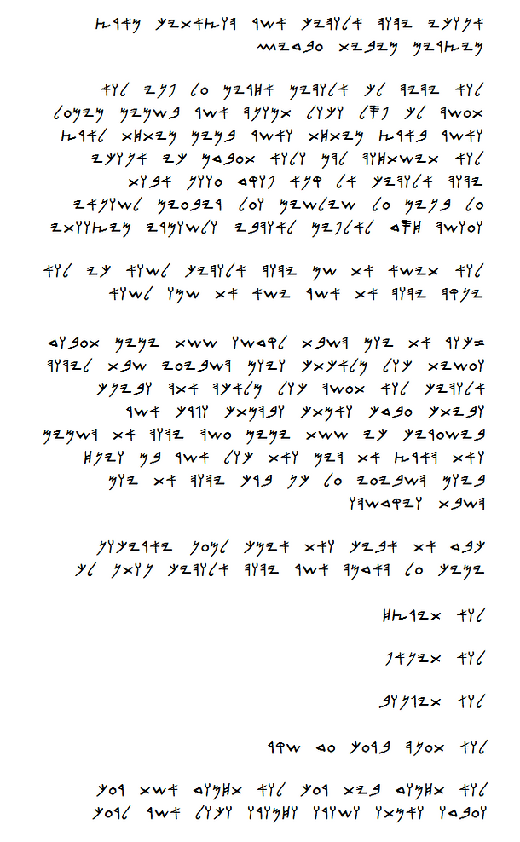

**Late Hebrew - (Dead Sea Scrolls)**

**Modern Square Script Hebrew**

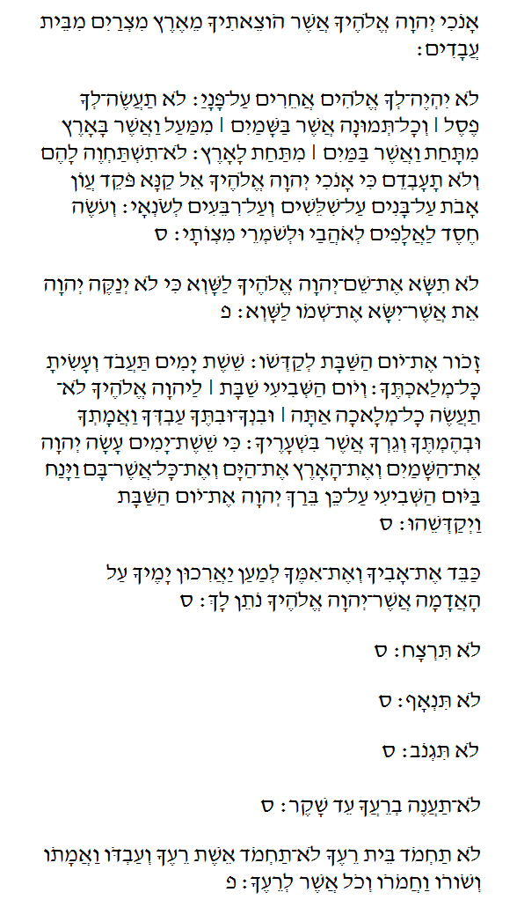

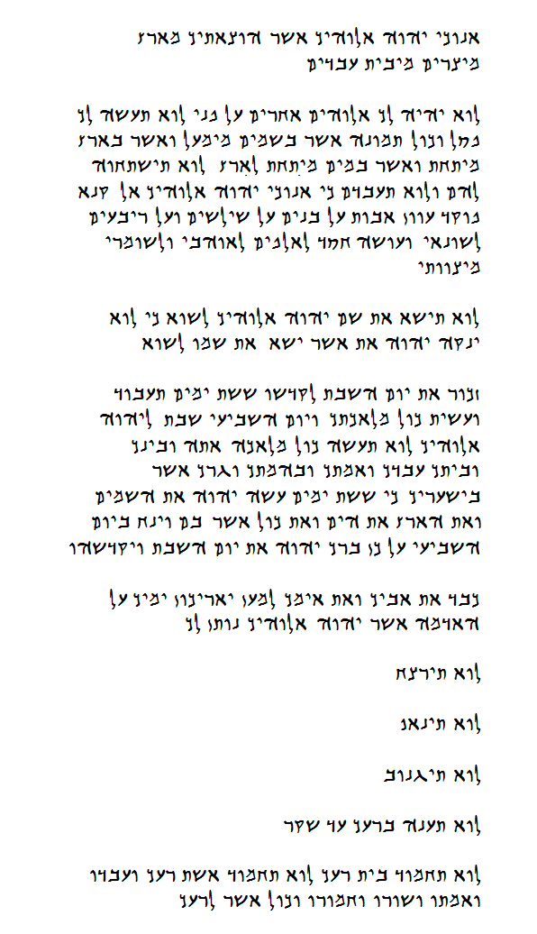

Greek Alphabet Charts:

***Note:*** *One form of Gematria is to give the final or "soffit" letter forms their own value as per the chart above. Other more common forms of Gematria assign the same numerical value to the 5 soffit forms as the corresponding non-soffit form letters.*

Please note the author of this website does not claim to be an expert in the languages considered herein. The things shown here represent some of the things this websites author has discovered while personally studying Hebrew and God's word.